EXPERIMENT 6: Finite Word length Effects
EXPERIMENT 6.1: Uniform Quantization and Quantization Error Analysis of a Discrete-Time Sinusoidal Signal Using MATLAB
clc;
clear;
close all;
%% Signal
fs = 1000; f = 50;
t = 0:1/fs:0.1;
x = sin(2*pi*f*t);
%% Quantization Levels
L = [8 16 32];
colors = {'r','g','m'};
figure;
for i = 1:length(L)
% Quantization
xq{i} = round((x + 1) * (L(i) - 1) / 2) * (2 / (L(i) - 1)) - 1;
% Error & MSE
e{i} = x - xq{i};
mse(i) = mean(e{i}.^2);
% Plot Quantized Signals
subplot(4,1,i+1);
stairs(t,xq{i},colors{i},'LineWidth',1.2);
title(['Quantized Signal (' num2str(L(i)) ' Levels)']);
grid on;
end
% Original Signal
subplot(4,1,1);
plot(t,x,'LineWidth',1.5);
title('Original Signal'); grid on;
% Display MSE
fprintf('MSE for 8 Levels = %f\n', mse(1));
fprintf('MSE for 16 Levels = %f\n', mse(2));
fprintf('MSE for 32 Levels = %f\n', mse(3));
%% Error Plots
figure;
for i = 1:3
subplot(3,1,i);
plot(t,e{i});
title(['Error (' num2str(L(i)) ' Levels)']);
grid on;
end
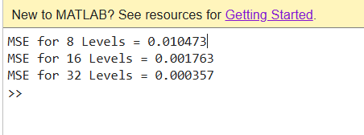
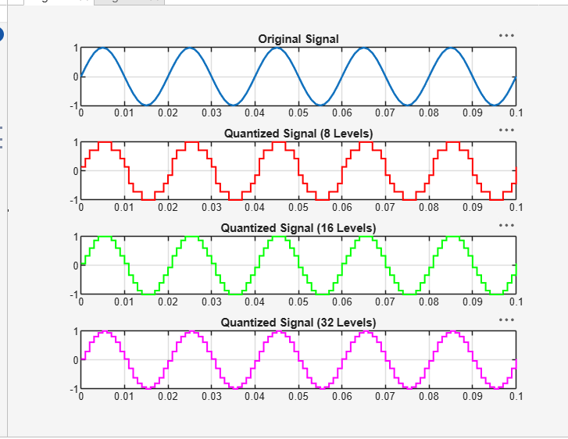

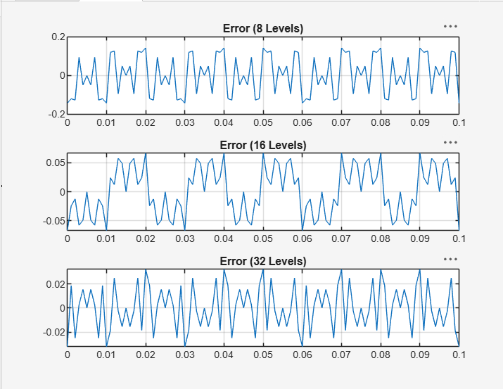
EXPERIMENT: 6.2 Analysis of Finite Word Length Effects in Digital Signal Representation Using Truncation and Rounding Techniques in MATLAB
clc; clear; close all
n=0:79;
x=sin(2*pi*n/40);
q=8;
xt=floor(x*q)/q;
xr=round(x*q)/q;
et=x-xt;
er=x-xr;
% Fig 1
figure
plot(n,x,'b',n,xr,'r','LineWidth',1.5)
grid on
title('Original vs Quantized')
legend('Original','Quantized')
% Fig 2
figure
plot(n,x,'b',n,xt,'r',n,xr,'g','LineWidth',1.5)
grid on
title('Truncation vs Rounding')
legend('Original','Truncated','Rounded')
% Fig 3
figure
stem(n,et,'r')
hold on
stem(n,er,'g')
grid on
title('Quantization Error')
legend('Truncation','Rounding')
% Fig 4
figure
bar([mean(et.^2) mean(er.^2)])
set(gca,'XTickLabel',{'Truncation','Rounding'})
grid on
title('MSE Comparison')
ylabel('MSE')
